**Login to another Instance**

**6.1 Retrieving the update set**

|  |  |
| --- | --- |
| Date | **25 June 2025** |
| Team ID | **LTVIP2025TMID29028** |
| Project Name | **Laptop Request Catalog Item** |
| Maximum Marks | **5 Marks** |

1. pen another instance in incognito window
2. Login with credentials
3. Click on all>> search for update sets
4. Select “Retrieved update set” under system update set
5. It open retrieved update set list and scroll down
6. Click on Import update set from XML

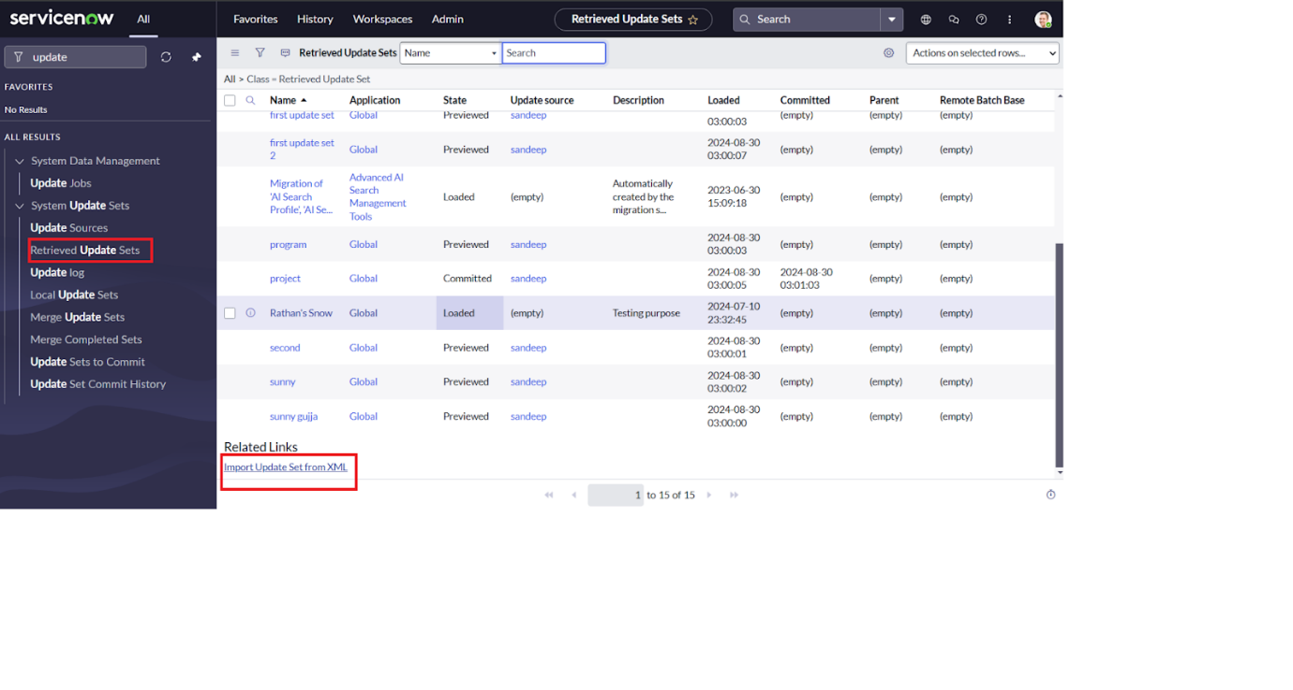

1. Upload the downloaded file in XML file
2. Click on Upload and it gets uploaded.

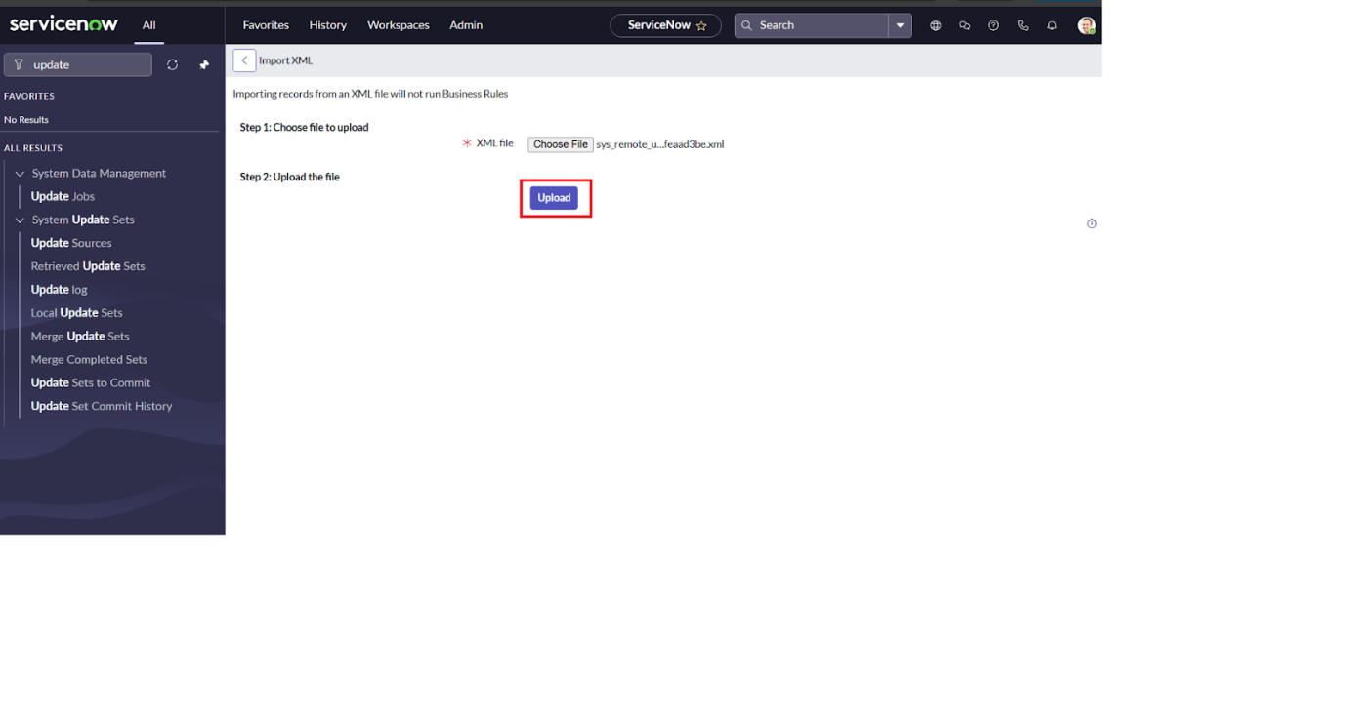

1. Open retrieved update set ‘laptop request project’
2. Click on preview update set
3. And click on commit update set
4. And also see the related tab updates
5. After commiting update set in this instance we get all updates which are done in the previous instance

